PHENIKAA UNIVERSITY

PHENIKAA SCHOOL OF COMPUTING



COURSE: SOFTWARE ARCHITECTURE
HOTEL MANAGEMENT SYSTEM

INSTRUCTOR: Vũ Quang Dũng
GROUP 7: Phạm Thế Thủy Hoàng (23010960 – K17-KTPM)
CREDIT CLASS: CSE703110-1-2-25(N01)

Ha Noi, March 6, 2026
Contents
1. Executive Summary 3
2. Testing & Verification 3
2.1 Unit Testing 3
2.2 Integration Testing 5
2.3 Verification Proof: Booking – Payment – Check-in Flow 7
3. Conclusion & Reflection 11
3.1 Lessons Learned 11
3.2 Future Improvements 11

1. Executive Summary
This project implements a Hotel Booking Management System that supports the end-to-end workflow of a real hotel: customers can browse rooms, create bookings, make payments, manage their wallet, and view booking history; receptionists can check guests in and out and manage service requests; administrators can manage rooms, services, staff, coupons, and reports. The system is architected using a layered architecture on top of Flask, with clear separation between controllers (HTTP layer), services (business logic), repositories (data access), and models (domain entities).
The backend lives under SRC/Arch and exposes REST-style JSON APIs (e.g. /api/bookings, /api/rooms, /api/auth/login, /api/wallet) through controller classes such as booking_controller.py, room_controller.py, user_controller.py, payment_controller.py, coupon_controller.py, checkin_controller.py, staff_controller.py, report_controller.py, and wallet_controller.py. These controllers rely on service classes (e.g. booking_service.py, room_service.py, payment_service.py, coupon_service.py) that encapsulate business logic and call repository classes (e.g. booking_repository.py, room_repository.py, coupon_repository.py) to access a MySQL database.
The frontend is implemented in SRC/UI as a set of HTML/CSS/JS pages for different roles: public pages for browsing rooms, authentication pages for login and registration, user pages for dashboard, my bookings, payment, and wallet, and admin pages for room and staff management and reports. The final outcome is a working multi-role hotel management application where the architecture supports modifiability, maintainability, and basic security and scalability for small-to-medium usage.

2. Testing & Verification
The main goal of testing is to ensure that:
- Booking and room availability logic works correctly (no overbooking).
- Payments and wallet operations are consistent with booking states.
- Authentication and authorization are enforced for protected endpoints.
- The frontend can interact smoothly with the backend APIs and present correct data.

2.1 Unit Testing
Unit tests verify individual components (functions, methods, or classes) in isolation, usually with dependencies mocked or stubbed. In this project, unit testing focuses on the business and data-access layers so that validation rules, state transitions, and data mapping behave as specified without requiring a live database or HTTP server.

- Service layer: booking_service.py, coupon_service.py, payment_service.py, wallet_service.py, and other services are tested for core logic—e.g. date overlap validation, coupon validity and discount calculation, wallet balance checks before payment, and refund amount computation on cancellation. Dependencies such as repositories are mocked so that tests are fast and deterministic.
- Repository layer: Repository methods (e.g. booking_repository.py/BookingRepository.find_available_rooms_by_date_range, WalletRepository.update_balance) can be unit-tested with an in-memory SQLite database or with mocks of the database connection to assert correct SQL behaviour and mapping from rows to domain models.
- Validation and helpers: Input validation (date ranges, positive amounts, required fields) and utility functions (e.g. in utils or middleware) are covered by unit tests to prevent invalid data from propagating to the database or API responses.

Tools such as pytest or unittest can be used, with pytest fixtures for shared setup and mocks (e.g. unittest.mock or pytest-mock) for repository and external dependencies.

Example unit tests:

1. BookingService – reject past check-in dates
def test_create_booking_rejects_past_check_in_date():
service = BookingService()
past_date = "2020-01-01"
with pytest.raises(ValueError):
service.create_booking(
guest_name="Alice",
room_type="standard",
check_in_date=past_date,
total_price=100.0,
)

2. BookingRepository – mapping database row to Booking model
def test_row_to_booking_maps_row_correctly():
repo = BookingRepository()
row = {
"id": 42,
"guest_name": "Bob",
"room_type": "deluxe",
"check_in_date": date(2026, 2, 10),
"check_out_date": date(2026, 2, 12),
"total_price": 300.0,
"status": "pending",
"room_id": 7,
"user_id": 5,
}
booking = repo._row_to_booking(row)
assert booking.id == "42"
assert booking.room_id == 7
assert booking.user_id == 5

3. PaymentService – prevent double payment
def test_process_payment_rejects_when_fully_paid(monkeypatch):
service = PaymentService()
# Fake repositories to avoid real DB
monkeypatch.setattr(service, "booking_repo", FakeBookingRepo(total_price=100.0))
monkeypatch.setattr(service, "repo", FakePaymentRepo(existing_amount=100.0))
with pytest.raises(ValueError):
service.process_payment(booking_id=1, amount=50.0, payment_method="cash")

2.2 Integration Testing
Integration tests verify that multiple components work together correctly—for example, API endpoints with the real (or test) database, or controller → service → repository flows. They ensure that the contracts between layers are respected and that end-to-end behaviour within the backend is consistent.

- API + database: Key flows are tested by sending HTTP requests to the Flask app (e.g. using Flask test client) against a dedicated MySQL database or an in-memory SQLite instance. Examples include: POST /api/bookings creates a booking and updates room availability; POST /api/payments correctly deducts wallet balance and updates booking status; GET /api/rooms returns only available rooms for the given date range.
- Authentication and authorization: Endpoints protected by require_auth, require_admin, or require_receptionist_or_admin are tested with valid and invalid X-User-Id headers (and optionally role) to confirm that forbidden access returns 401/403 and that allowed roles succeed.
- Cross-layer flows: Integration tests cover scenarios such as create booking → process payment → check-in → check-out, and cancel booking → refund to wallet, ensuring that service and repository interactions and transaction boundaries behave correctly under a single application context.

These tests may use the same Flask application factory and a test configuration that points to a test database, with cleanup (e.g. transaction rollback or truncated tables) between tests to avoid side effects.

Example integration tests:

1. Booking API + room availability
def test_create_booking_reserves_room(client, db):
# Arrange: seed one available room of type "standard" in the test DB
room_id = seed_room(db, room_type="standard", status="available")
payload = {
"guest_name": "Alice",
"room_type": "standard",
"check_in_date": "2026-02-10",
"check_out_date": "2026-02-12"
}
# Act: call POST /api/bookings via Flask test client
response = client.post("/api/bookings", json=payload, headers={"X-User-Id": "1"})
# Assert: booking is created and room status becomes 'reserved'
assert response.status_code == 200
data = response.get_json()
assert data["booking"]["room_id"] == room_id
assert get_room(db, room_id).status == "reserved"

2. Payment API + wallet deduction
def test_wallet_payment_deducts_balance(client, db, wallet_factory):
wallet = wallet_factory(user_id="1", balance=500.0)
booking_id = seed_booking(db, user_id="1", total_price=200.0)
payload = {
"booking_id": booking_id,
"amount": 200.0,
"payment_method": "cash"
}
response = client.post("/api/payments", json=payload, headers={"X-User-Id": "1"})
assert response.status_code == 200
updated_wallet = get_wallet(db, "1")
assert updated_wallet.balance == wallet.balance - 200.0

3. Authorization on admin endpoint
def test_normal_user_cannot_access_admin_rooms(client, db):
# User without admin role tries to access admin-only rooms endpoint
response = client.post("/api/rooms", json={}, headers={"X-User-Id": "normal-user"})
# Expect 403 Forbidden returned by require_admin middleware
assert response.status_code == 403

2.3 Verification Proof: Booking – Payment – Check-in Flow
Test Scenario: A user successfully books a room, pays using wallet, and is checked in and later checked out by a receptionist.

Step | Action | Expected Result | Actual Result | Status
1 | User registers and logs in via UI | User account is created and authenticated | OK | Pass
2 | User browses rooms and selects room type and date range | Available rooms are displayed | OK | Pass
3 | User confirms booking (POST /api/bookings) | Booking is created with pending status and assigned room_id | OK | Pass
4 | User opens payment page and pays via wallet | Wallet balance is verified, payment is processed, booking status updated to paid | OK | Pass
5 | Receptionist views upcoming arrivals and performs check-in | Check-in record is created, room status is updated | OK | Pass
6 | Receptionist performs check-out at end of stay | Check-out summary is generated, room is released | OK | Pass
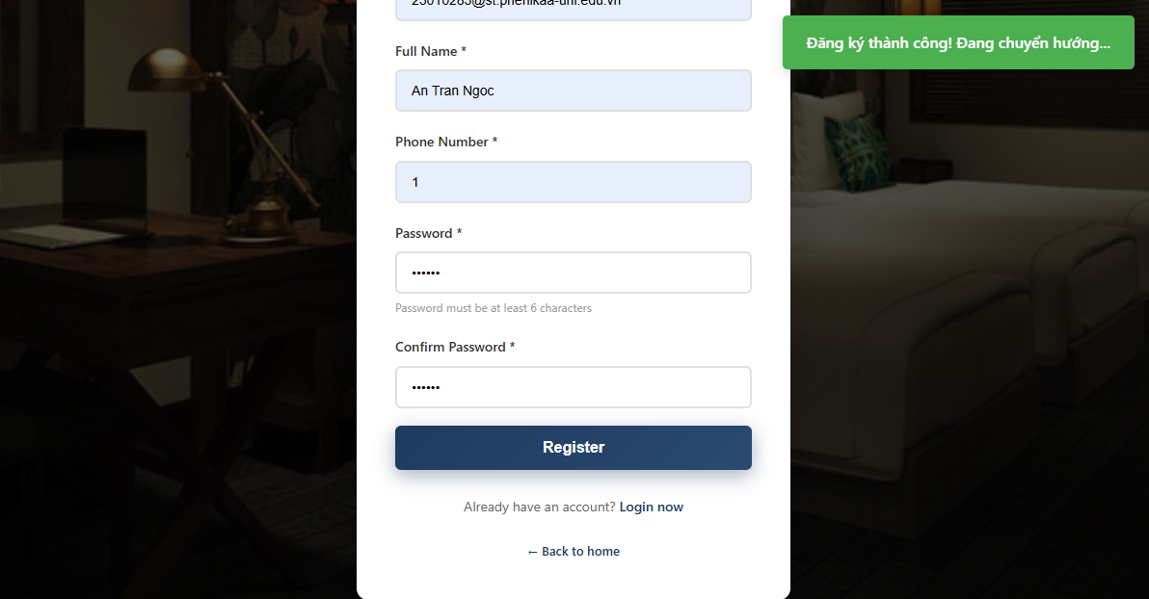
Figure 13: Register completed
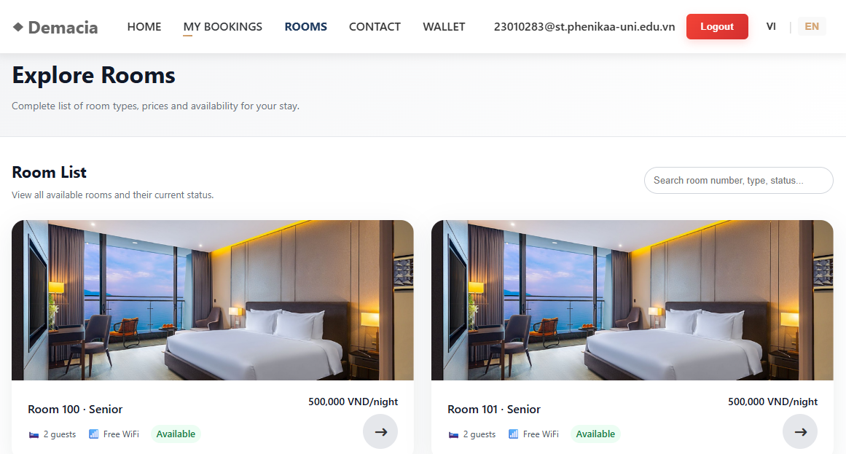
Figure 14: Search rooms
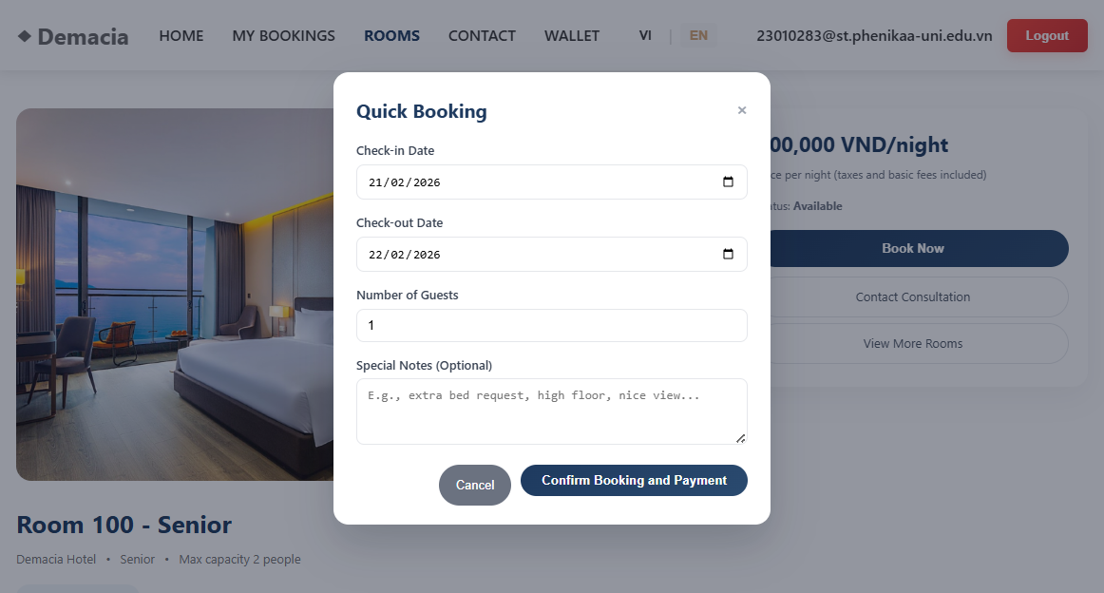
Figure 15: Booking
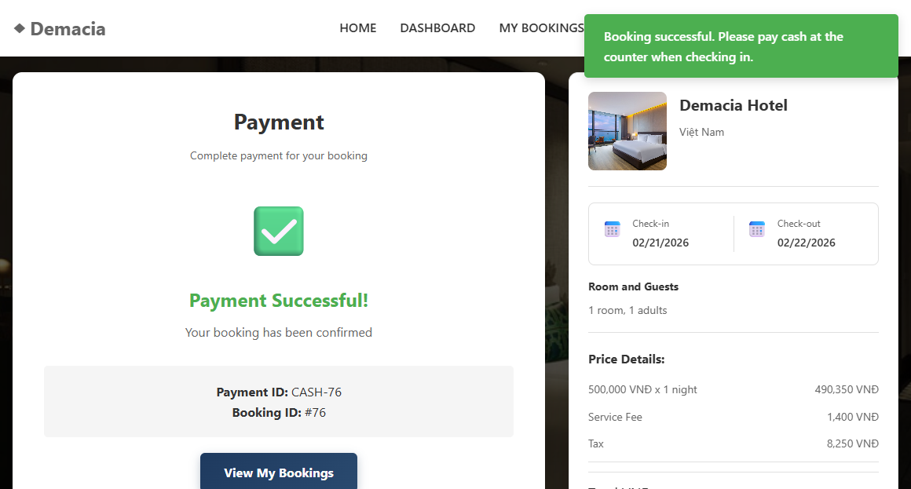
Figure 16: Payment completed
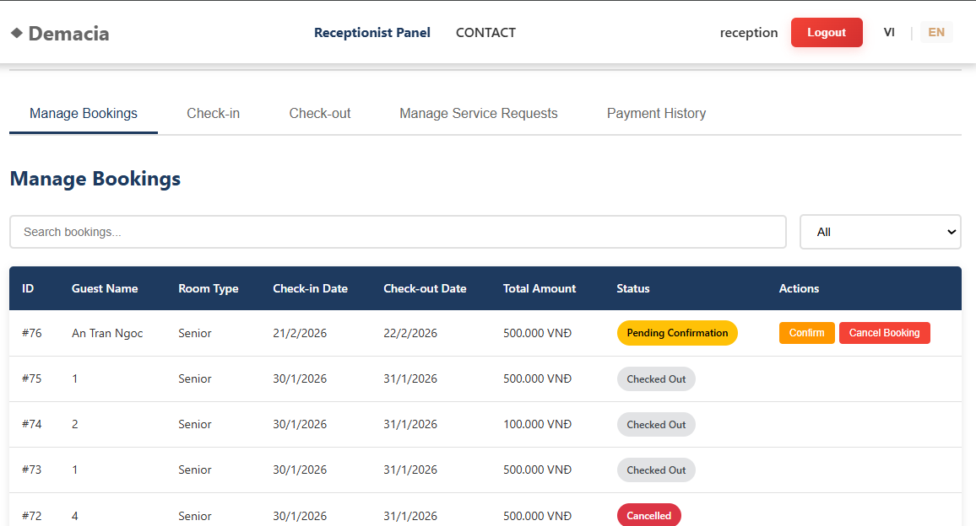
Figure 17: Manage bookings
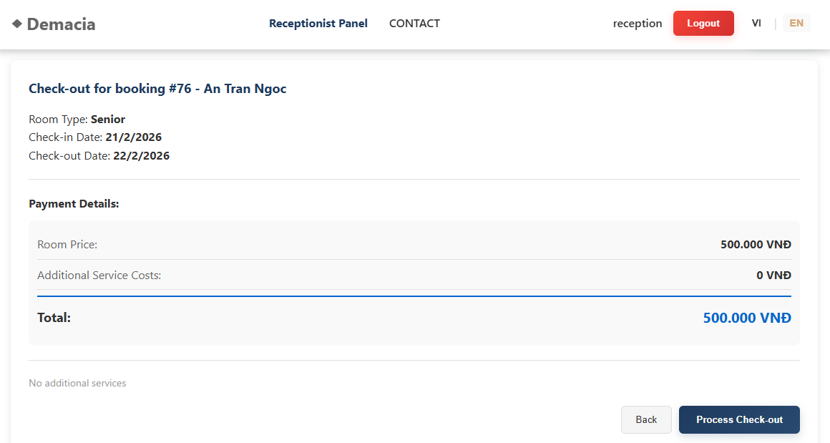
Figure 18: Checkout
Additional tests include:
- Attempting to book the same room and date range twice, which should fail due to the SQL overlap logic in BookingRepository.find_available_rooms_by_date_range.
- Attempting to access admin endpoints as a normal user, which should be blocked by require_admin or require_receptionist_or_admin middleware.
- Applying expired or inactive coupons, which should be rejected by CouponService.
- Verifying that cancellation triggers appropriate room release and, if applicable, wallet refunds, and that booking status is updated to 'cancelled'.

3. Conclusion & Reflection
This project successfully implements a multi-role Hotel Booking Management System using a layered Flask backend and a static HTML/CSS/JavaScript frontend. The layered structure with controllers, services, repositories, and models has proven effective in separating concerns, making it easier to reason about booking, payment, and reporting flows. The system satisfies the main functional requirements (room browsing, booking, payment, check-in/check-out, wallet, coupons, services, reporting) and achieves key architectural goals such as modifiability, maintainability, and basic security.

3.1 Lessons Learned
Value of Clear Layering: Explicit separation between controllers, services, and repositories significantly reduced coupling. When business rules changed (e.g.,
new validation for booking dates or coupon constraints), modifications could be
localized mainly in the service layer.
Handling Data Consistency: Implementing correct booking and payment flows required careful handling of transactions and state transitions (pending, paid, cancelled, checked_in, checked_out). The repository methods and service logic had to be designed to avoid partial updates (e.g., reserving a room but failing to create a booking).
Security & Roles: Introducing middleware-based decorators for authentication and role-based access control made it easier to secure endpoints consistently across
the application. This pattern helped enforce that only appropriate roles can perform sensitive operations like managing rooms, staff, or viewing reports.
Integration with a Real Database: Working with MySQL and explicit SQL queries (instead of an ORM) provided deeper understanding of SQL, transactions, and how to map between relational tables and Python objects.

3.2 Future Improvements
1. Strengthen Authentication & Authorization:
- Adopt a more robust token-based authentication mechanism (e.g., JWT) with secure storage on the client and token refresh logic.
- Enhance password policies, add account lockout after repeated failed logins,
and introduce audit logging for security-sensitive operations.
2. Enhance Reporting:
- Extend ReportService and related repositories to produce richer analytics such as revenue by room type, monthly/seasonal trends, average length of stay, and service usage statistics.
- Provide export options (CSV/PDF) and more visual dashboards in the admin UI.
3. Improve Scalability & Deployment:
- Containerize the application (Docker), use environment-specific configurations,
and deploy on a cloud platform.
- Introduce a reverse proxy/load balancer and, if necessary, separate the booking, payment, and reporting domains into independently scalable services.
4. UX & UI Enhancements:
- Improve responsiveness and interactivity of the frontend, potentially integrating a modern frontend framework for complex admin views.
- Add user notifications (email or in-app) for booking confirmation, payment receipts, and check-in reminders.
5. Logging, Monitoring & Error Handling:
- Implement structured logging and monitoring (e.g., using a logging framework and a dashboard) to quickly detect issues in production.
- Standardize error responses across controllers to provide consistent feedback to Frontend developers and end users.

